IMPACT SOLUTIONS-Biometric Tablet System Architecture
We envision the Bio tablet to have multiple capabilities with capacity to be deployed in various industries. The Demo offline application should have all the sufficient menus enabling Impact solutions to demonstrate to potential clients the device capabilities. In this document we have attempted to break down the application menus for easier design and development by your engineers.

POS MENUS SCREEN SHOTS

- Home screen
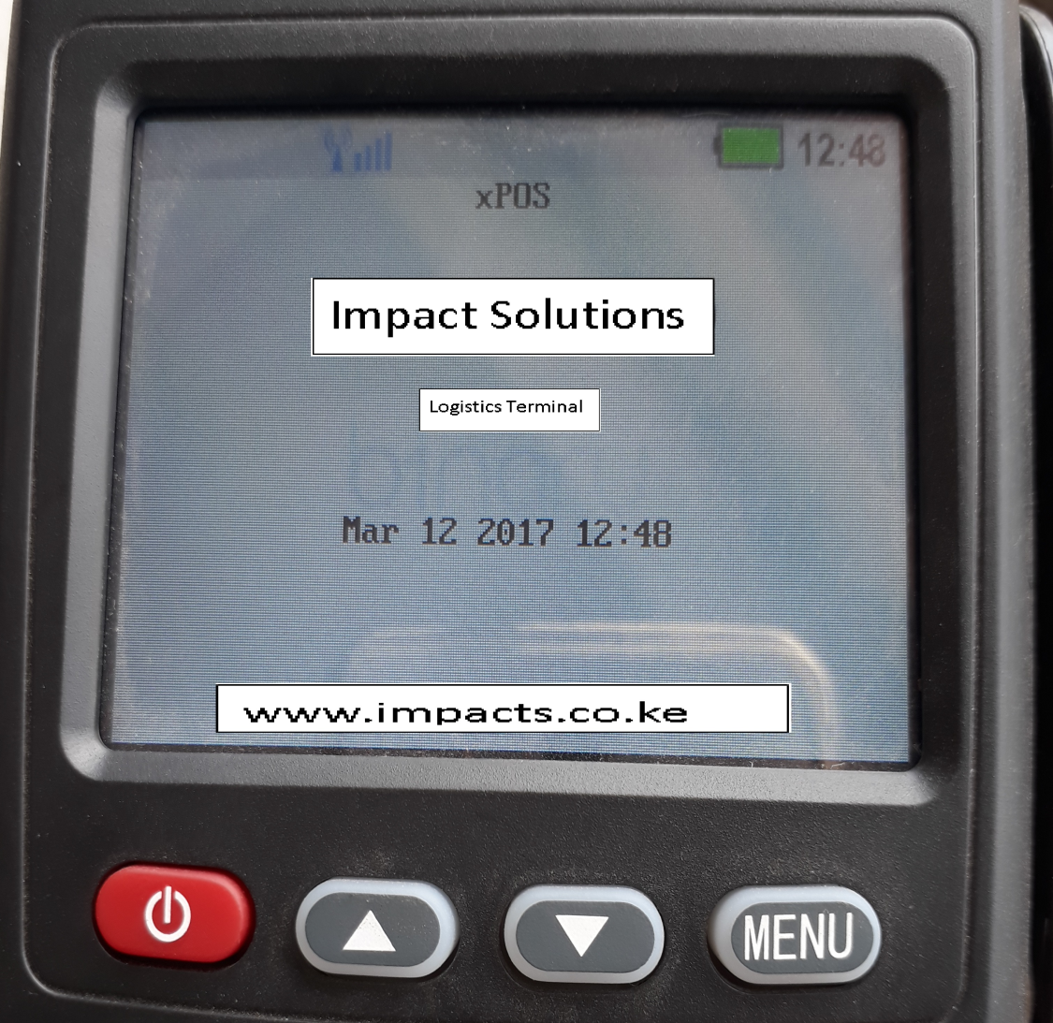
- Login ID
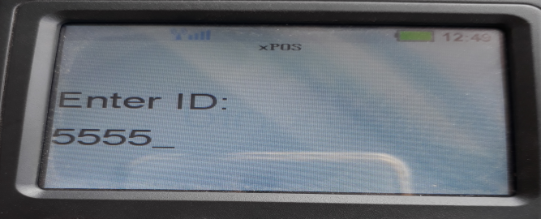

3. Login Passwords:
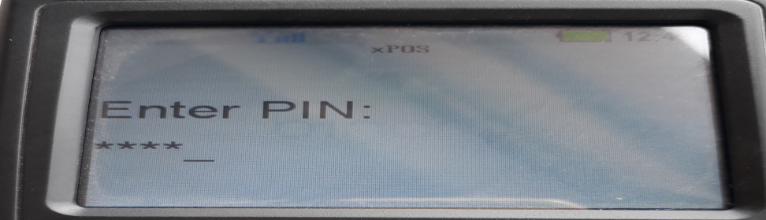

- Service level

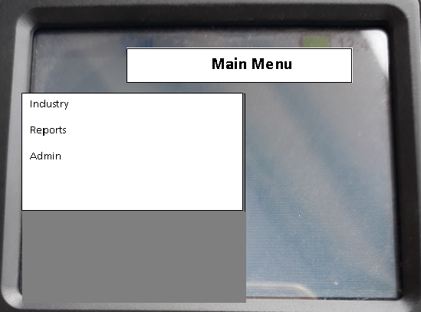

- Industry
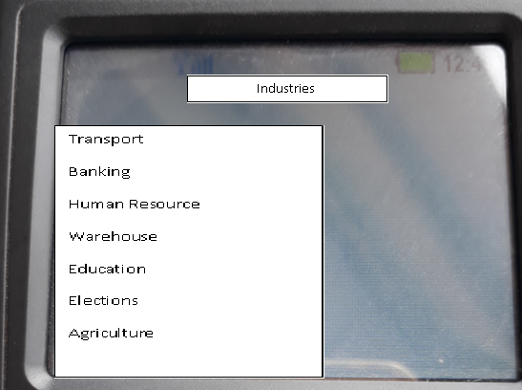

- Transport Management Module

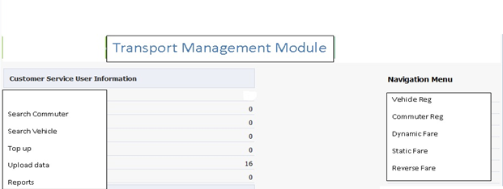

- Vehicles Registration
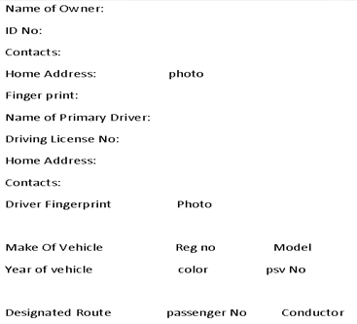

- Commuter Registration
NB: system will automatically allocate unique registration number to each commuter. The tablet admin to search/filter commuters by ID Number, Name and Registration number

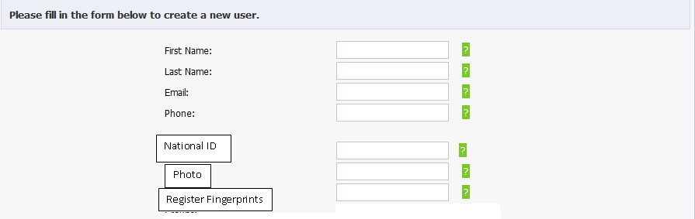

8) The fare is set by the admin, when this option is operational commuter will just place their finger on the bio and system will deduct preset fare automatically.
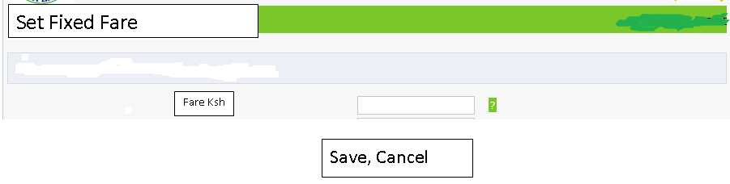

9 b) Dynamic Fare: When this option is activated, the Tablet operator will be able to key in the amount to be deducted动态费用:当这个选项被激活时，平板电脑操作员将能够在被扣除的金额中关键字。
Dynamic Fare

Minimum: _______________Maximum_____________

Save, Cancel

9 c) Search Commuter Account
ddf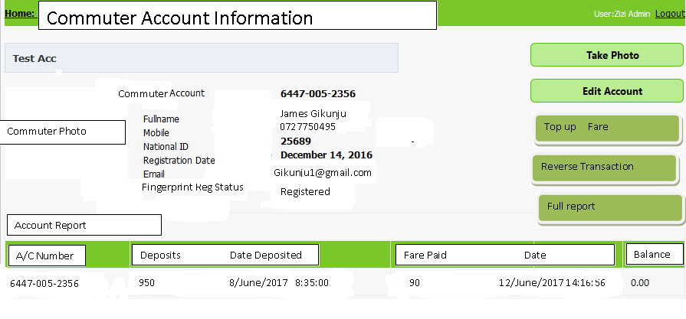 NB: During top up the system will request commuter finger prints to complete the process and produce receipt在上面的系统中，系统会请求通勤者指纹来完成这一过程并产生收据
Reverse transaction:

Reverse Fare
Search Commuter:

Amount:

Reverse, Cancels

2. Banking Application
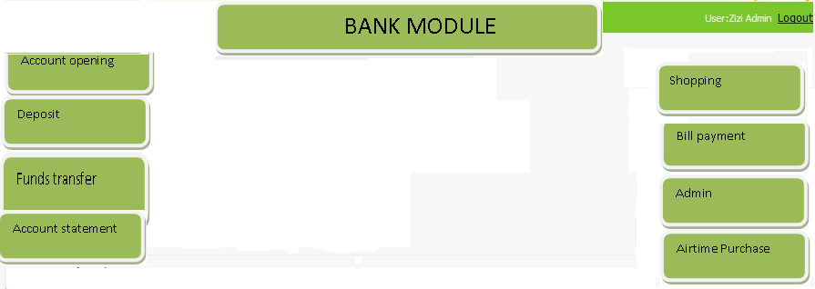
- Bank Registration

Bank Name:
Address:
Branches:
Contacts:
Account types:

- Bank customer registration
Customer Names:
Gender:
Finger Prints:
Marital Status:
Contacts:
Branch
Account types:

- \Bank customer information
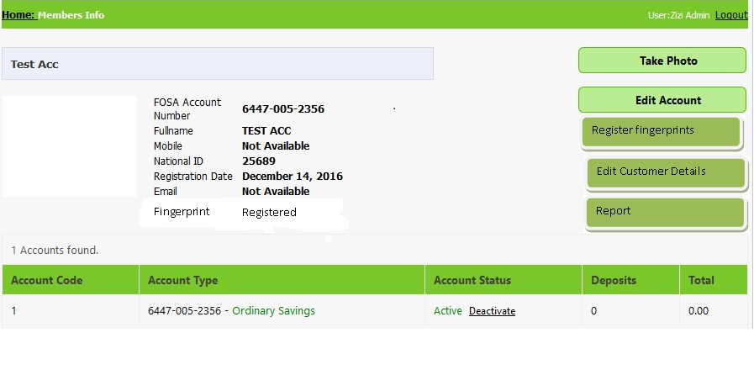

3. Student management module:

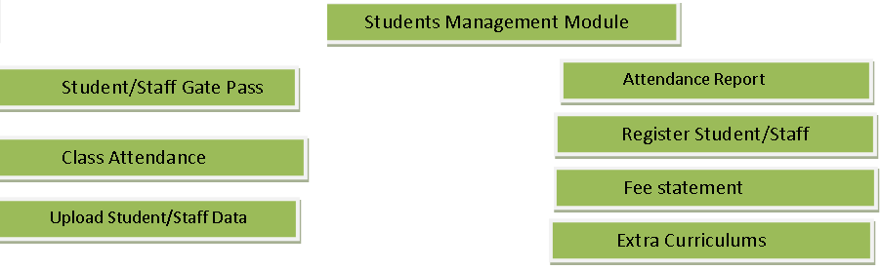

- Student /staff Gate Pass
Student will place their finger on the tablet and and given ok or Negative depending on:
学生会将手指放在平板电脑上然后根据不同的情况给出不同的选择

- If student registered or not
- 如果学生注册了
- Fee payments
- 费用支付
- Clocking time i.e. if student late depending on attendance time table and clocking rules set in the database.
- 计时，例如，如果学生迟到取决于考勤表和数据库中设定的规则
- Any other condition i.e. if student suspended from school will return negative(“No Admission”)
- 任何其他情况，例如，如果学生休学，将会返回(“no admission”)
Staff Gate pass: Staff will place finger and given “ok” or “No Admission” depending on whether Finger registration ok.
工作人员会将手指按下“ok”或者“不No ADMIN”，这取决于手指的是否注册

- Device will record clocking time and produce reports for both students and staff.

设备将记录时间并为学生和工作人员生成报告。

- Class Attendance:
Students and lecturers will clock every time they attend a lecture. System will produce attendance report.

学生和讲师每次上课都要计时。系统将会产生出勤率报告

- Register student or Staff

Capture basic student information: 基本信息
- Student names
- Capture Fingerprints
- Admission Number
- Capture photo
- Admission Date 入学时间
- Nationality 籍贯
- Gender
- Date of Birth
- Department 年纪
- Boarding type(day, Hostel part time) Hostel No,
- Email
- Cell phone
- Next of kin/Guardhosian minimum of two(guardians names, contacts, photo)
- Next of kid contacts
See below for student registration page format.

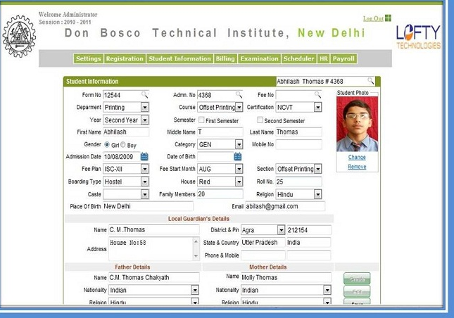

8. Agri-Business Management Module
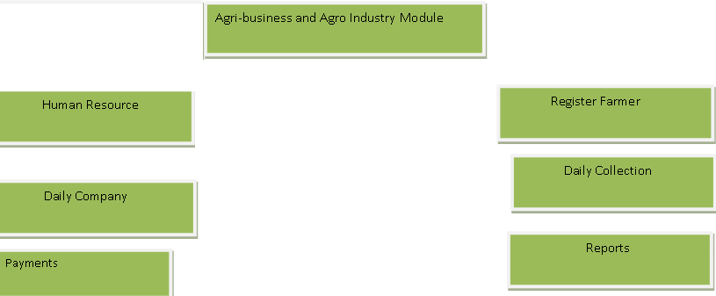

b) Human resource management module

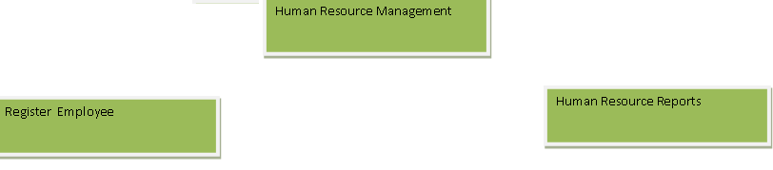

c) Register employee: Capture following details注册员工:获取以下详细信息

- Names
- Fingerprints
- ID number
- Gender
- Registration Number
- Contact
- Job Title/Group
- Salary
- Date of birth
- Date Employed
- Home town
- Collection Route
- Nature of Employment i.e. Permanent, contractor, day laborer
d) Human resource basic Report
- Employee report

4) Farmers registration module
- Names1
- Fingerprints1
- ID number1
- Gender1
- Contact1
- Date of birth1
- Home town1
- Number of Animals
- Registration Number1
- Collection Route

b) Farmers report: basic report showing farmer’s details

5) Daily Collection: device operator presses this button and it prompts the farmer to place his bio finger and amount collected is keyed in, it issues receipt showing Name of farmer, Amount collected (liters).
6) Payments: system to calculate amount owed to farmer based on his/her daily collection and amount per liter set in the system. The payment process: operator selects payment, system prompts farmer for finger, then prompts Amount, and issues receipts showing balance, Name of farmer, amount paid per litter, next payment date. System should be able to provide basic reports.
6) Employee clocking system: system to allow registration of employee, departments, nature of work, type of employment i.e. permanent, contractor etc
Employee places his finger print and system record time and generates reports showing absentees, late comers, and employee on time. System to allow clocking out.
5）每日收集：设备操作员按下该按钮，并提示农民放置生物指，收集的金额被扣上，发出收据显示农民姓名，收取金额（升）。
6）付款：系统根据系统每日收集和每公升数量计算欠农民的数量。支付流程：运营商选择支付，系统提示农民手指，提示金额，发放收益表，余额，农民姓名，每窝支付金额，下一个付款日。系统应该能够提供基本报告。
6）员工计时系统：允许员工，部门，工作性质，就业类型，永久性，承包商等的登记制度
员工将他的手指打印和系统记录时间，并生成报告显示缺席者，迟到的人员和员工按时。系统允许计时。

PARKING/TICKETING SYSTEM
Pay parking: Motorist places finger on the tablet, system checks if finger registered and any money in the account to credit.
Top up: motorist places finger, system checks if motorist record properly registered, prompts system admin to key in amount , amount is credited in the account and given receipt.
Vehicle status: This module checks if the vehicle parking has been paid for. Operator keys in vehicle Reg number, and it returns result if paid or not.
System should allow to set parameters i.e. Parking fee per hour, per day, per month, special discounts.

停车/托盘系统
付费停车：驾驶员将手指放在平板电脑上，系统检查手指是否注册，并且帐户中的任何钱都可以信用。
补充：驾驶员手指，系统检查驾驶记录是否正确注册，提示系统管理员输入金额，金额记入账户并收到。
车辆状态：该模块检查车辆停车是否已经支付。车辆 编号中的操作键，如果支付，则返回结果。
系统应允许设置参数，即每小时停车费，每月，每月，特别折扣。

